**Front-End UI/UX Mini Project**

**1. Title Page**

* **Project Title**: Art Portfolio Grid
* **Submitted By**: 
  + *Team Members-*

*Yoihen Wahengbam (2462175)*

*Nevita Sharon Y (2462121)*

* + *College-E-mail id-*

[*yoihen.wehengbam@btech.christuniversity.in*](mailto:yoihen.wehengbam@btech.christuniversity.in)

[*Nevita.sharon@btech.christuniversity.in*](mailto:Nevita.sharon@btech.christuniversity.in)

* **Course**: *UI/UX Design Fundamentals*
* **Instructor Name**: *Nagaveena.*
* **Institution**: *Christ University*
* **Date of Submission**: *13/08/2025*

**2. Abstract**

The Art Portfolio Grid project focuses on creating a visually appealing and responsive platform to showcase artwork effectively. Using HTML5 and CSS3, the design implements a grid layout to organize images with accompanying descriptions, ensuring clarity and visual balance. The portfolio adapts to various screen sizes through responsive design techniques, enhancing accessibility for all users. Optional features such as image sliders or lightbox modals provide an engaging viewing experience. Image optimization ensures fast loading times without compromising quality. This project delivers a professional, organized portfolio structure suitable for artists to present their work online.

**3. Objectives**

* **Create a grid layout using HTML and CSS for artwork display.**
* **Implement image galleries or sliders (optional).**
* **Ensure the portfolio is responsive and accessible.**

**4. Scope of the Project**

* Designing and developing a **portfolio grid page** (portfolio.html) to display artwork thumbnails or tiles.
* Creating **individual artwork detail pages** (artwork1.html, artwork2.html, etc.) with larger images and descriptions.
* Implementing **responsive design** using CSS Grid or Flexbox for optimal viewing on mobile, tablet, and desktop.
* Applying **consistent layout and styling** for a professional, uniform appearance.
* Using **image optimization techniques** to ensure fast loading and smooth performance.
* Including **optional lightbox or modal features** for enlarged image viewing.

**5. Tools & Technologies Used**

* **HTML5** – Structures the portfolio pages and organizes artwork content.
* **CSS3** – Styles the layout, colors, typography, and grid arrangement.
* **CSS Grid** – Creates the responsive portfolio grid layout for artworks.
* **Flexbox** – Aligns and distributes elements within sections for better layout control.
* **Image Optimization Tools** (e.g., TinyPNG, Squoosh) – Reduces image file size for faster loading.
* **Lightbox/Modal Scripts** (optional) – Enhances the viewing experience for larger artwork images.

**6. HTML Structure Overview**

* **portfolio.html** displays all artworks in a grid layout.
* **artworkX.html** provides details for each artwork.
* **CSS Grid** handles the portfolio layout, while **Flexbox** aligns items inside sections.

**7. CSS Styling Strategy**

* **Mobile-first approach** – Begin with styles for small screens, then enhance layouts for tablets and desktops using media queries.
* **Use CSS Grid** – Arrange artwork thumbnails in a flexible, responsive grid layout.
* **Flexbox for alignment** – Align navigation items, footer content, and elements within each grid card.
* **Consistent spacing and typography** – Apply uniform margins, padding, and font styles across all pages for visual harmony.
* **Image styling** – Ensure images are responsive with max-width: 100% and maintain aspect ratio.
* **Hover effects** – Add subtle transitions like zoom-in or shadow on artwork thumbnails for interactivity.
* **Color scheme and contrast** – Use a simple, consistent color palette that complements artwork while ensuring readability.
* **Reusable classes** – Create modular CSS classes for grid items, buttons, and text to maintain cleaner, scalable code.

**8. Key Features**

* **Responsive design** that adapts to mobile, tablet, and desktop devices.
* **Grid-based layout** for organized and visually appealing artwork display.
* **Individual artwork detail pages** with larger images and descriptions.
* **Optional lightbox or modal** feature for enhanced image viewing.
* **Image optimization** for faster loading without losing quality.
* **Consistent styling** for uniformity across all artworks.
* **Clean navigation** for easy browsing through portfolio sections.
* **Hover effects** to create an interactive and engaging user experience.
* Ask ChatGPT

**9. Challenges Faced & Solutions**

* **Ensuring the layout remains responsive across different devices and screen sizes.**
* **Maintaining image quality while keeping file sizes small for faster loading.**
* **Achieving consistent styling across multiple portfolio and detail pages.**
* **Designing a layout that highlights artwork without distracting from it.**
* **Adding interactive elements like hover effects without affecting performance.**
* **Ask ChatGPT**

**10. Outcome**

* Achieved a clean, consistent, and visually engaging front-end layout
* All key components function as intended using just HTML and CSS
* Learned about layout responsiveness and UI hierarchy in depth

**11. Future Enhancements**

* **Integrate a CMS (like WordPress) to allow easy addition and management of artworks.**
* **Add search and filter options for quick navigation through the portfolio.**
* **Implement dark mode for improved user experience and accessibility.**
* **Include a slideshow or carousel for automatic artwork showcasing.**
* **Enable user comments or feedback on individual artworks.**
* **Support multilingual content to reach a wider audience.**
* **Add SEO optimization for better online visibility.**
* **Integrate e-commerce functionality to allow artwork sales directly from the portfolio.**
* **Ask ChatGPT**

**12. Sample Code**

**<section class="artwork-card">**

**<img src="images/artworks/art1.jpg" alt="Sunset Dreams Artwork">**

**<div class="artwork-info">**

**<h2>Sunset Dreams</h2>**

**<p>A vibrant semi-abstract acrylic painting capturing the warm hues of a glowing sunset over tranquil waters.</p>**

**<a href="artwork1.html" class="view-more">View Details</a>**

**</div>**

**</section>**

**This code creates a single artwork card for the portfolio grid.**

**The <img> tag displays the artwork image (art1.jpg) with a descriptive alt text for accessibility.**

**13. Screenshots of Final Output**

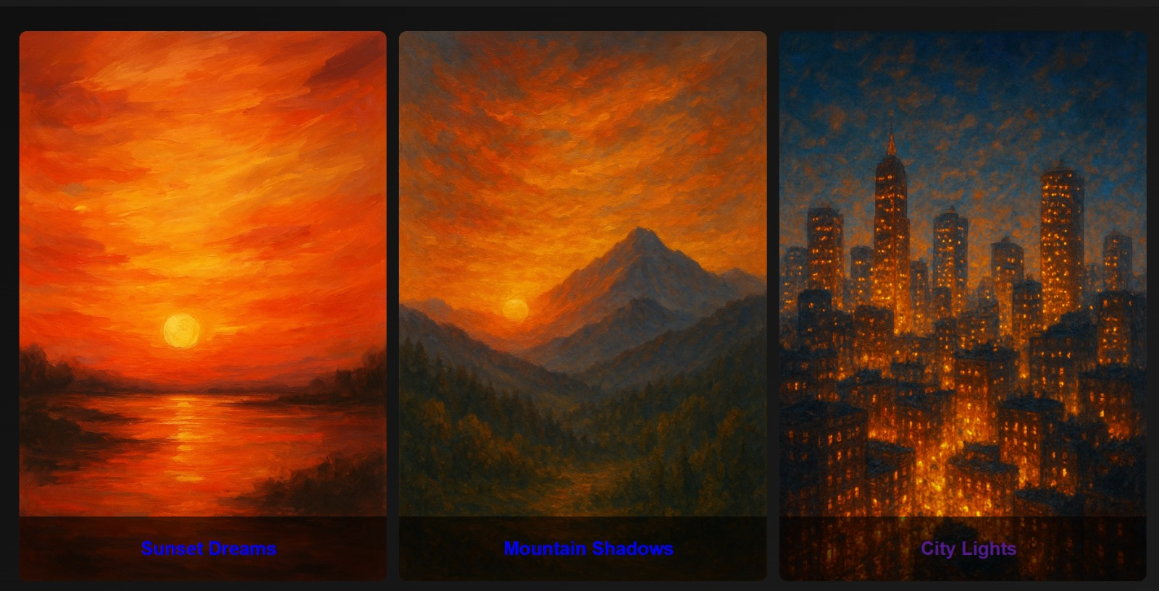

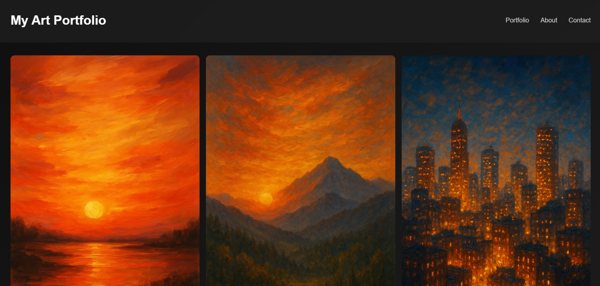

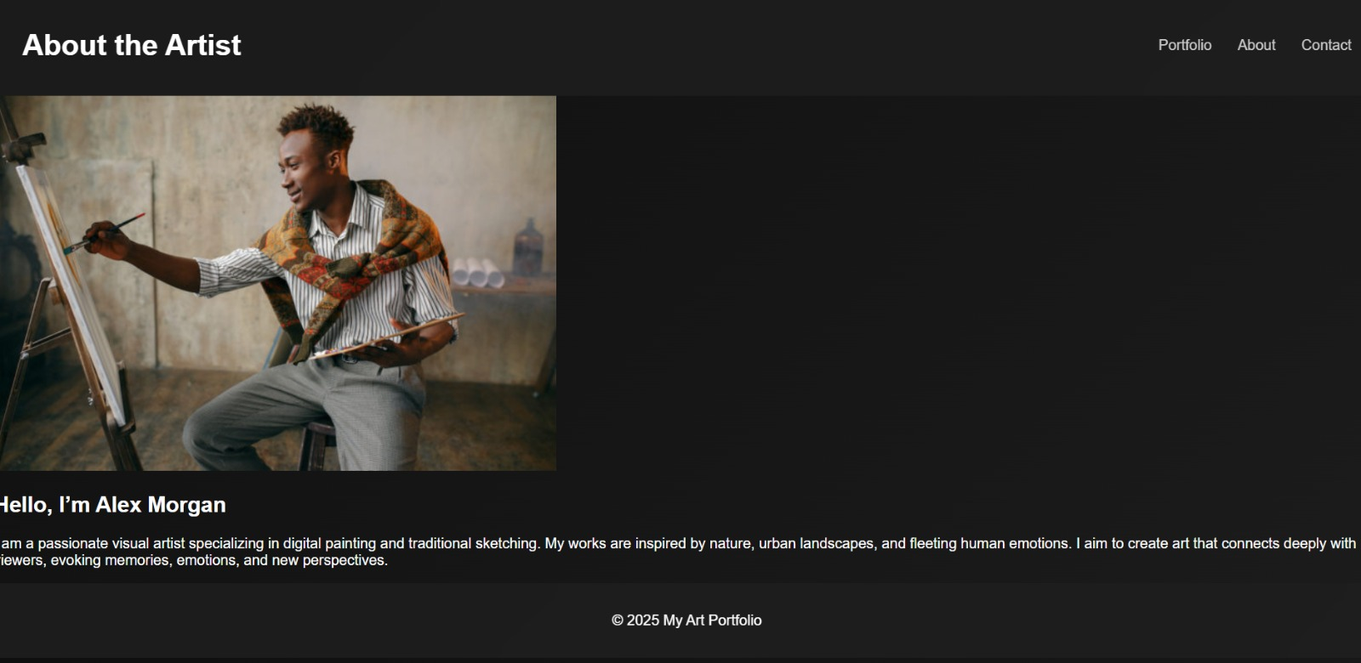

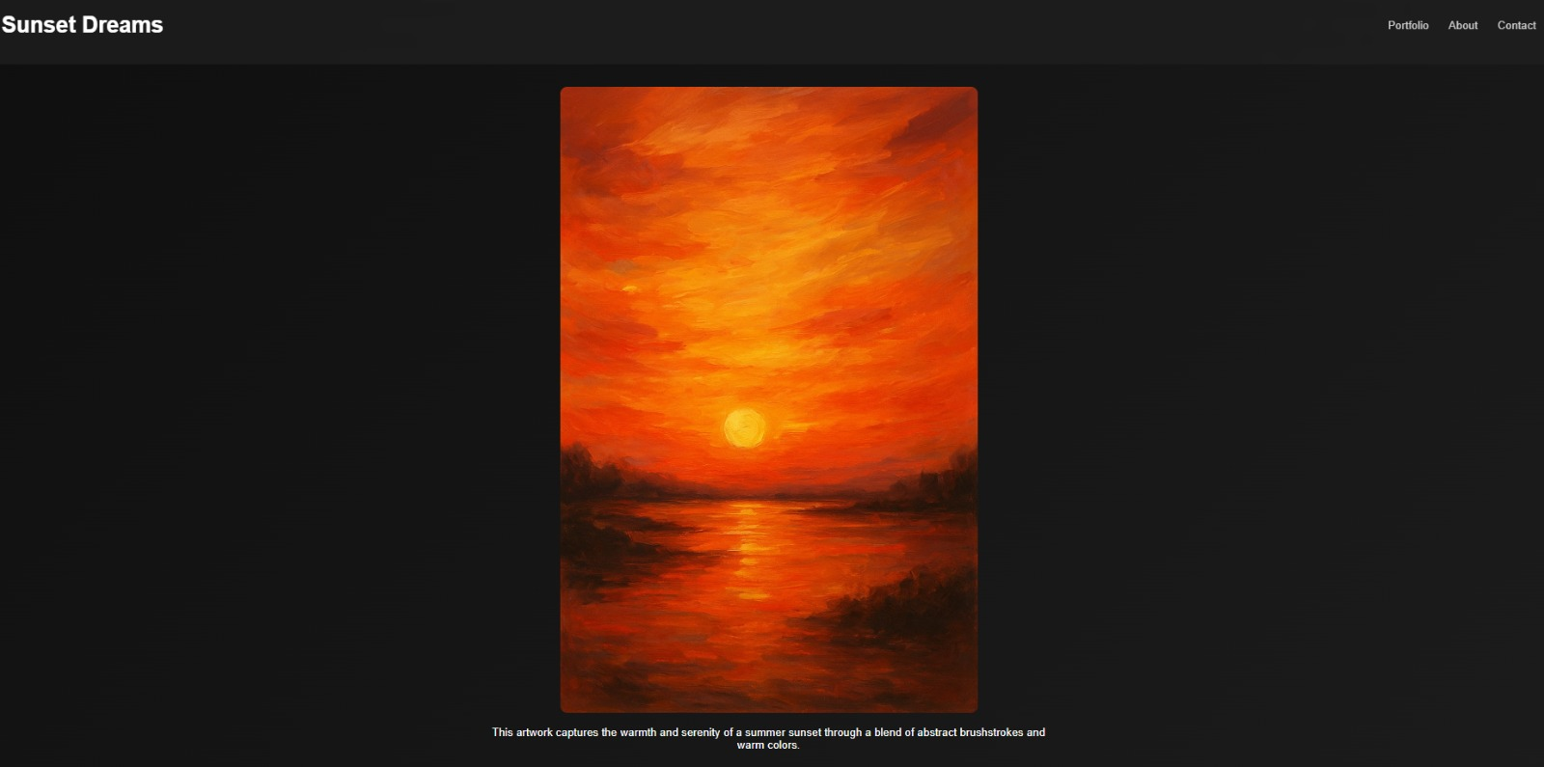

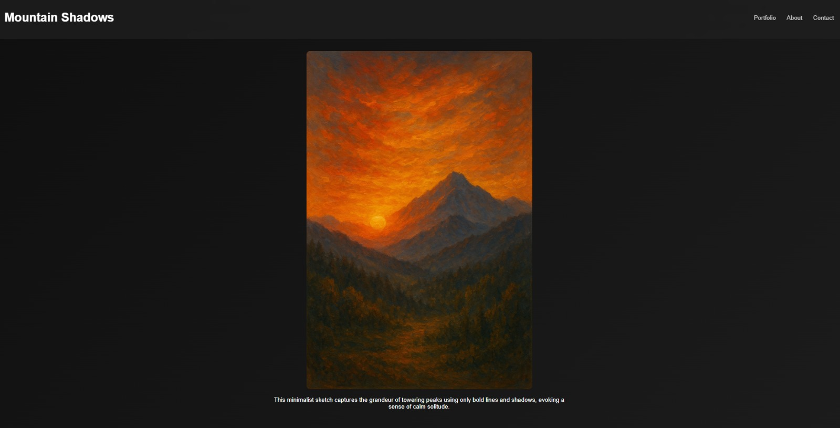

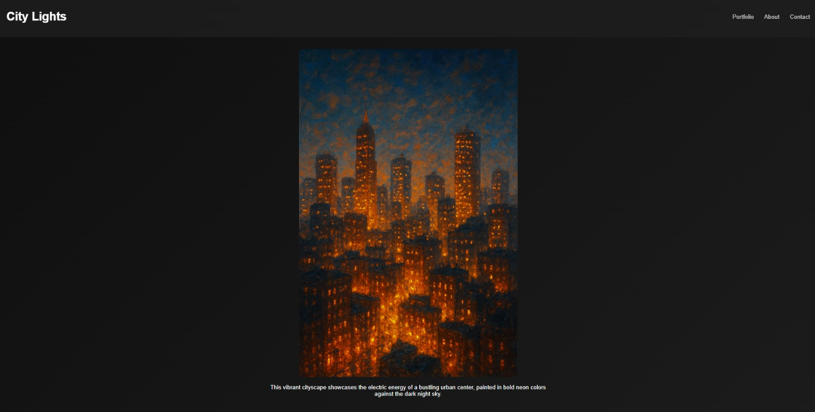

**14. Conclusion**

The Art Portfolio Grid project successfully delivers a clean, organized, and responsive platform for showcasing artwork in an engaging manner. By implementing HTML5 and CSS3 with CSS Grid and Flexbox, the design ensures a professional and accessible layout across devices. The grid structure allows artworks to be displayed uniformly, while detail pages provide in-depth descriptions and larger images. Image optimization techniques enhance performance without compromising visual quality. The minimalist design approach keeps the focus on the artwork itself, ensuring a visually pleasing experience for visitors. Optional features like lightbox viewing and hover effects add interactivity without overwhelming the design. The project meets its objectives by combining functionality, aesthetics, and usability. Overall, it provides a strong foundation for artists to present and expand their portfolios online.

**15. References**

* L&T LMS: https://learn.lntedutech.com/Landing/MyCourse